Karsten Vogel
Saxophones, composer, bandleader

Karsten Vogel was born 1943 in Copenhagen, Denmark. He played the alto Saxophone from the age of 14, and after a few years of practicing he became part of the modern jazz scene in his hometown with combos co-led with his brother playing the drums. They even won the Danish championship in jazz (!) in 1963. 1966 – 68 he was a member of John Tchicai’s Cadentia Nova Danica as a musician and composer.
In 1967 he formed Burnin Red Ivanhoe that would show up to be a legendary group on the Danish and European jazz/rock-scene. They have been playing well over 1.500 concerts, some together with names like Jimi Hendrix, Uriah Heep, Incredible Stringband and Black Sabbath. The group still is active performing mostly in Denmark. It has made several TV- and radio shows and has released 10 albums, the latest in 2013.
In 1972 Karsten Vogel formed another legendary group, pioneers of instrumental fusion Secret Oyster, which he led until its split up in 1977. The group toured with among others Captain Beefheart, Herbie Hancock, Shakti and Weather Report and released four albums. As a result of increasing international reputation these albums has been re-issued in USA and that prompted the band to reunite, since making tours in both Denmark and USA.
Karsten Vogel also has been working with combos under his own name, with his working unit Birds of Beauty and with famous Danish actor Frits Helmuth. He also has been a featured soloist with Robin Taylor’s prog units.
He has played concerts in Denmark, Sweden, Norway, Finland, Iceland, Faroe Islands, UK, Germany, France, Greece, India, Dubai, USA and Japan.

Karsten Vogel is a respected composer of modern music. He has received several grants from the Danish Ministry of Culture and since 2004 he has been honoured with a lifetime grant as composer.

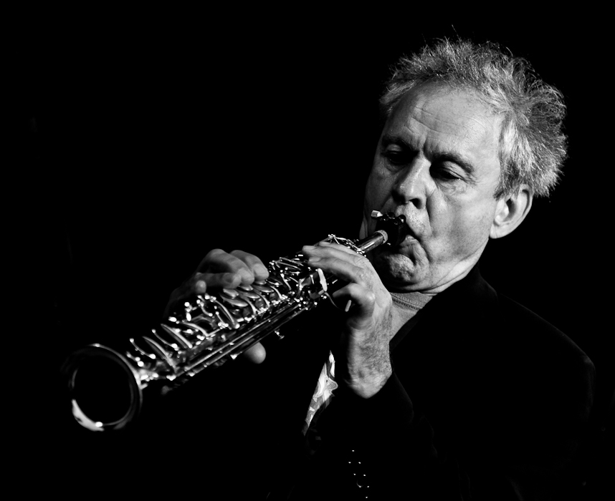

“There aren’t many alto saxophonists to whom I’d rather be listening. He has a lovely tone - slender, fibrous and very human - and a shallow vibrato: a highly distinctive combination. If you listen to one of his improvisations and just concentrate on the shaping of his phrases, it can be a good reminder of how inventive and unpredictable a great jazz musician can be.” (Richard Williams 2016)

